**SUPERPOSITION THEOREM**

**Main Circuit:**

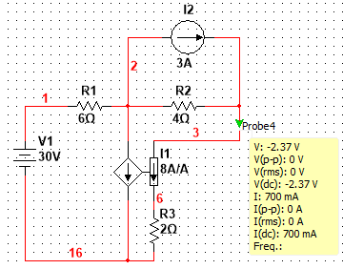

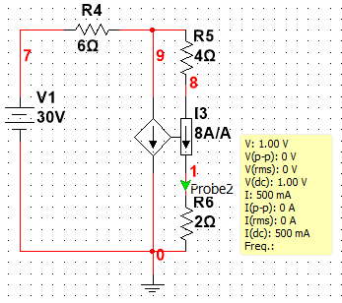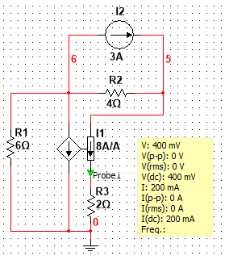**Classical Superposition:**

**Modified Superposition:**

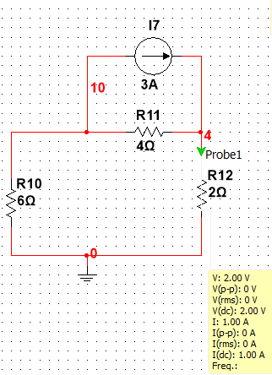 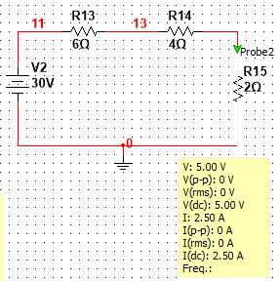

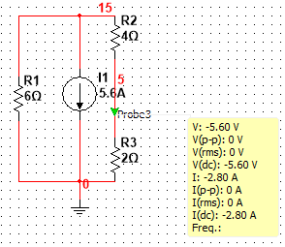 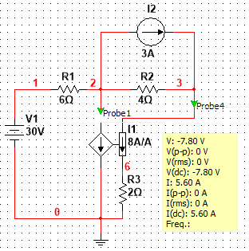

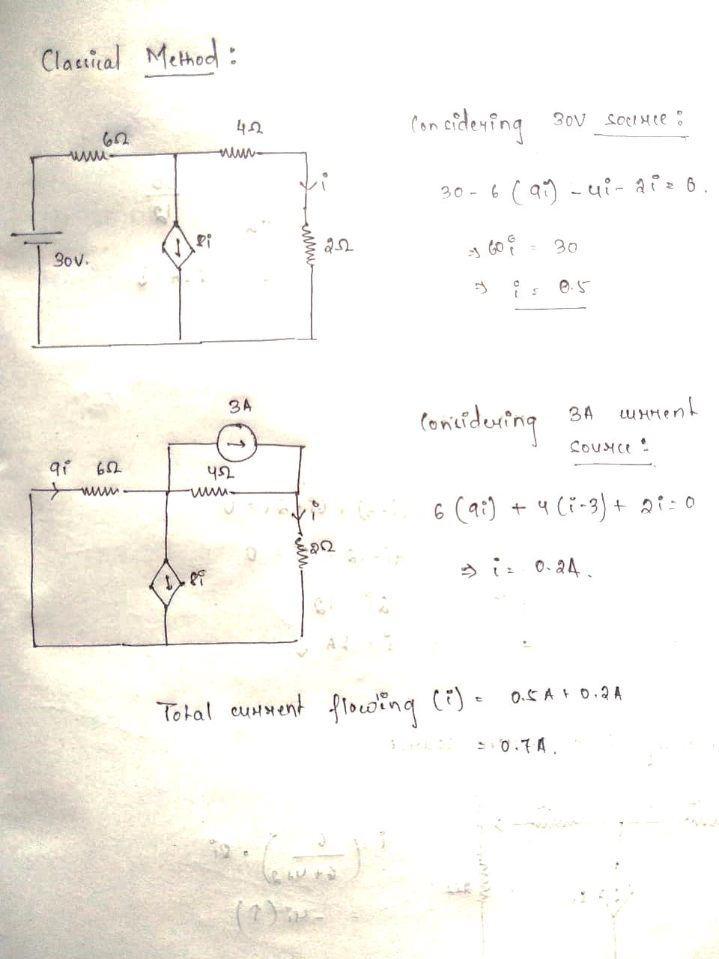

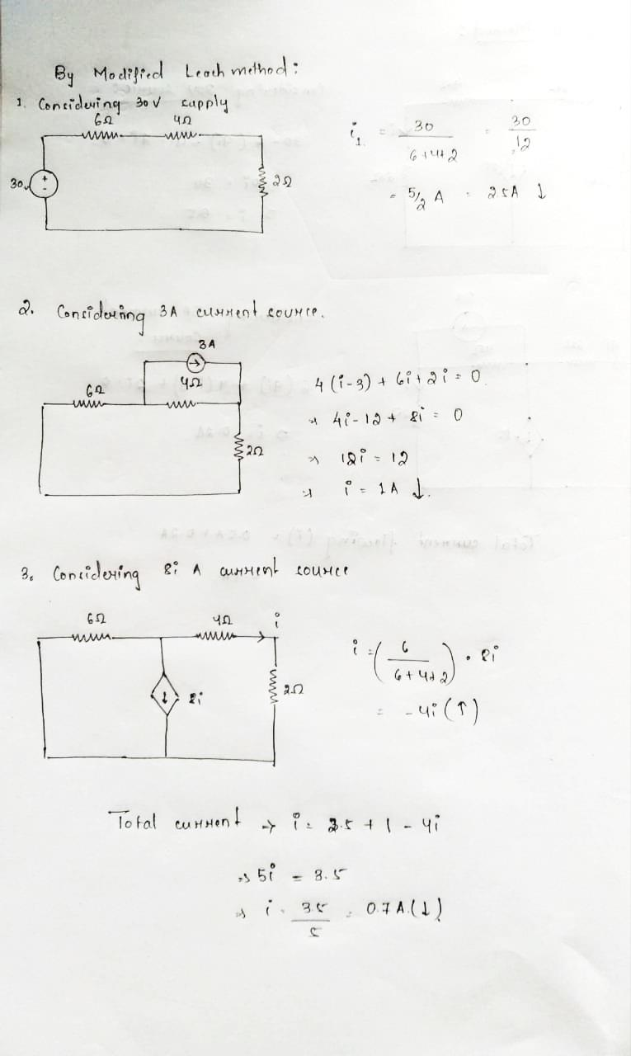

1. **Table**:

|  |  |  |  |  |
| --- | --- | --- | --- | --- |
| Quantity/Method | Calculated | | Simulated | |
| Classical | Modified | Classical | Modified |
| Current I1 due to 3A | 200mA | 1A | 200mA | 1A |
| Current I1 due to 30V | 500mA | 2.5A | 500mA | 2.5A |
| Current I1 due to 8 I1 A | - | -4i1 | - | -2.8A |
| Total current I1 | 700mA | I1 = 1A + 2.5A  –4I1  I1 = 700mA | 700mA | 700mA |

1. A network in which the parameters of resistance, inductance, and capacitance are constant with respect to current or voltage, and in which the voltage or current of sources is independent of or directly proportional to other voltages and currents, or their derivatives, in the network is called **linear network**.

A network or circuit in which the magnitude of the current remains the same when the voltage polarity is reversed is called a **bilateral network**.

1. The solution from modified superposition theorem is found to be matching with the classical superposition theorem. And the modified superposition theorem is easier to apply in calculations than the classical superposition theorem.